[Test Plan] Website Belajar Bareng Onrender

Document Status | [FINAL]
Test Plan Creator | Muh Rafli Shofa
Test Plan Reviewer | - Ridhwan  - Reviewer_Tim_Digital_Scola

Introduction

Overview Feature to be tested
The Test Plan has been created to communicate the test approach to team members. It includes the objectives, scope, schedule, risks and approach. This document will clearly identify what the test deliverables will be and what is deemed in and out of scope.
This Test Plan is made to ensure that all features on the http://belajar-bareng.onrender.com/ website function properly and meet the criteria according to user needs.

Goals and Objective
The Belajar Bareng Onrender website is a simple web-based learning simulation platform that provides several features such as Login, User List Dashboard, Add User, Update User, and Delete User.
The testing activities are conducted using Manual Testing with the following objectives:
- Login Feature Testing
To ensure users can log in successfully using valid credentials and receive proper error messages when using invalid credentials, including scenarios with stable and unstable connections.
- Add User Feature Testing
To ensure new users can be added correctly based on the defined requirements.
The test scenarios include:
- Valid username and age
- Empty username
- Empty age
- Invalid age format

Test Item

No | Feature | Test Item
#1 | Login | - Login with valid credentials  - Login with invalid credentials  - Login with user doesn’t exist  - Logout function work properly
#2 | Add User | - Add user with valid data  - Add user with empty username  - Add user with empty age  - Update user function work properly  - Delete user function work properly

In Scope Testing
No | Feature | Requirement / Design specifications
#1 | Login | Username and Password are mandatory fields, error message displayed for incorrect password  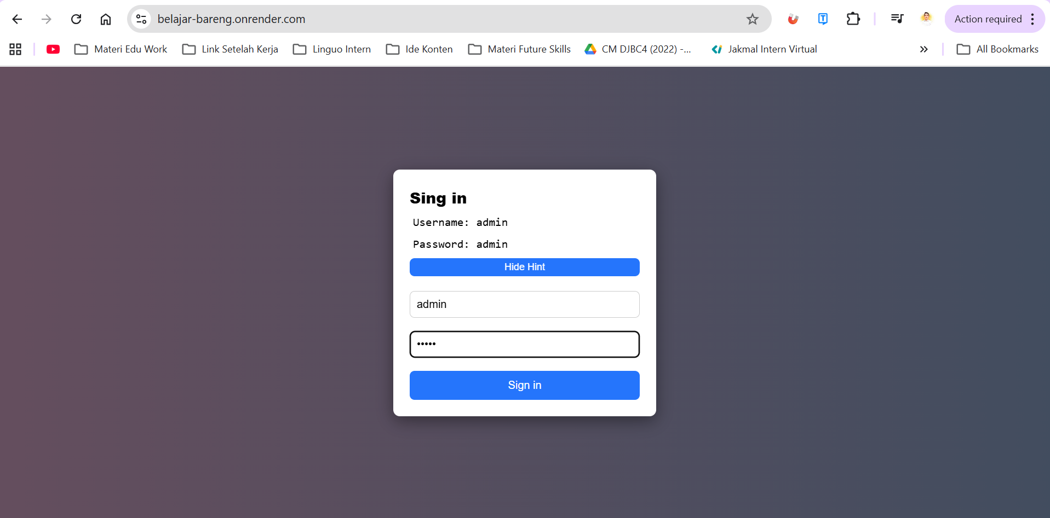
#2 | Add User | Username and Age are mandatory, Username max length is 10 characters, age in numerical form and no more than 3 digits  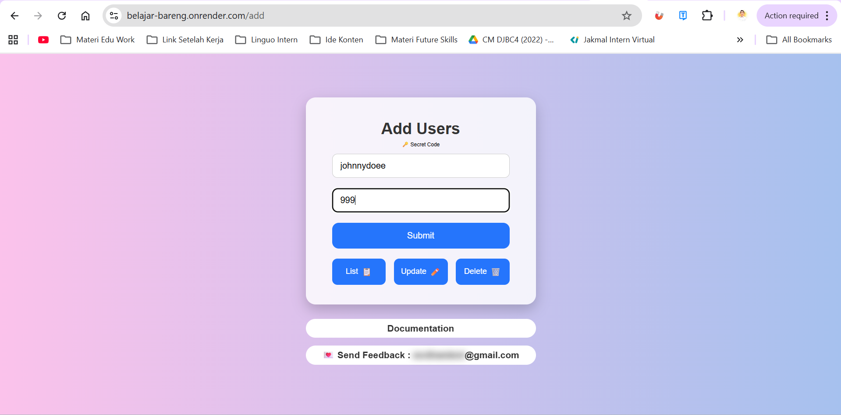  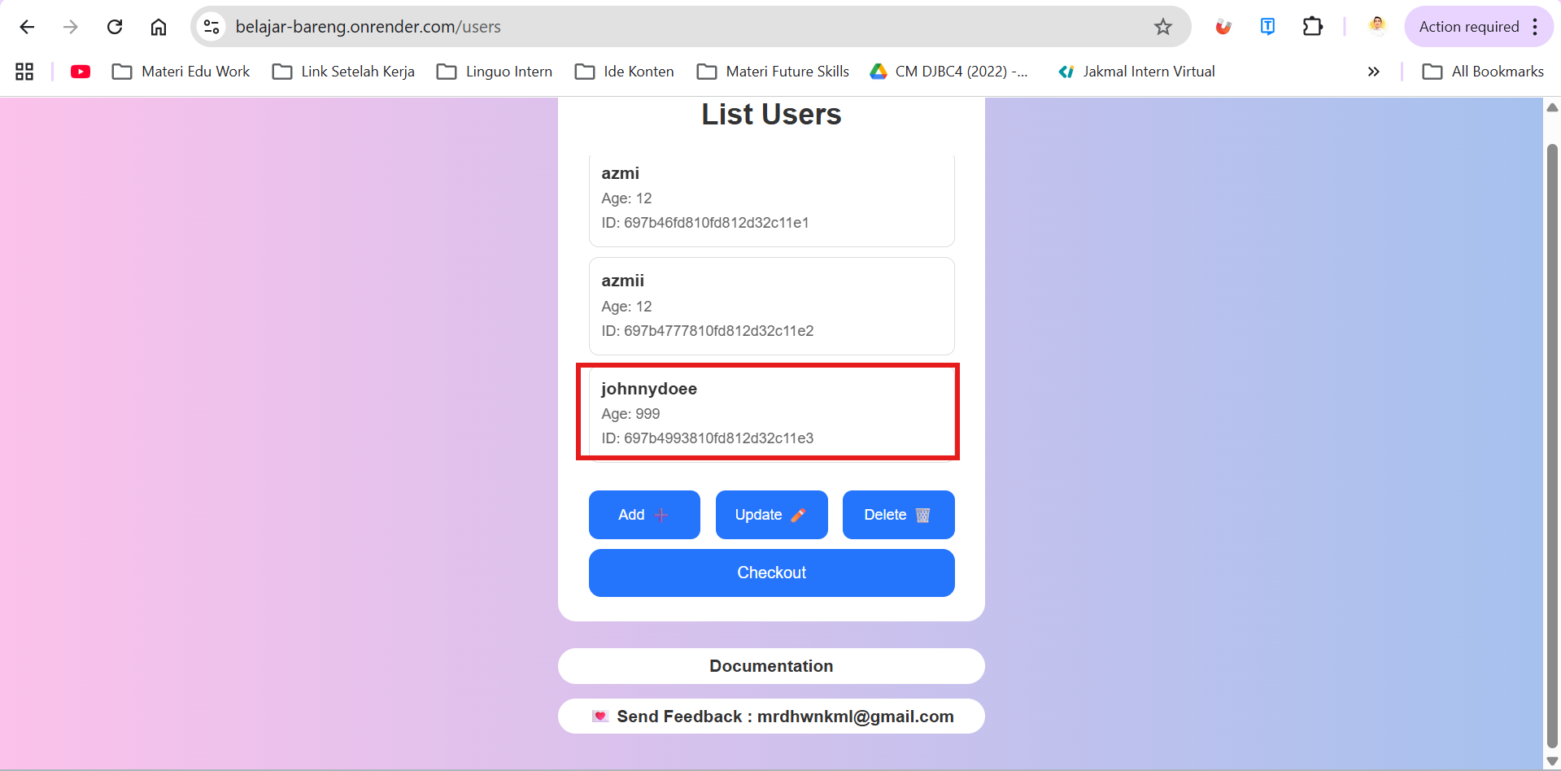

Out of Scope Testing
List the features of the software / product which will not be tested.

No | Feature | Reasons
#1 | Register | This testing phase focuses only on Login and Add User features

Testing Approach
The testing process uses Exploratory Testing and Black Box Testing techniques.

The tester explores the website without prior knowledge of the system implementation to ensure that the application works correctly from a user perspective and does not produce functional errors during usage.

Test Environment
- Website: https://belajar-bareng.onrender.com/
- Operating System: Windows 10
- Environment: Production
- Browser: Google Chrome, Microsoft Edge, Mozilla Firefox

Test Deliverables
- Test Plan (this document itself):
- Test Case:
- Test Script (if any):
- Test data (if any):
- Defect Report: [link]
- Test Report: [link]

Testing Timeline

No | Task | Estimation Time |  | Actual Time
No | Task | Start Date | Finish Date | Start Date | Finish Date
#1 | Develop Test Planning | 24 Jan 2024 | 25 Jan 2024 | 24 Jan 2024 | 25 Jan 2024
#2 | Develop Test Case | 25 Jan 2024 | 25 Jan 2024 | 25 Jan 2024 | 25 Jan 2024
#3 | Test Case Review | 26 Jan 2024 | 26 Jan 2024 | 26 Jan 2024 | 26 Jan 2024
#4 | Execute Test | 27 Jan 2024 | 28 Jan 2024 | 28 Jan 2024 | 29 Jan 2024
#5 | Retest Bug | 29 Jan 2024 | 30 Jan 2025 | 30 Jan 2025 | 30 Jan 2025

References
API Contact: N/A,
Design: Figma (if available)
Requirement Document: Internal Assignment Specification

